OPERATING SYSTEM LAB

**UDUMULA KOTI VENKATA DINESH REDDY**

**CB.EN.U4CYS21081**

**1.** **#include<stdio.h>**

**int main()**

**{**

**int bt[20],p[20],wt[20],tat[20],i,j,n,total=0,pos,temp;**

**float avg_wt,avg_tat;**

**printf("Enter number of process:");**

**scanf("%d",&n);**

**printf("\nEnter Burst Time:n");**

**for(i=0;i<n;i++)**

**{**

**printf("p%d:\n",i+1);**

**scanf("%d",&bt[i]);**

**p[i]=i+1;**

**}**

**//sorting of burst times**

**for(i=0;i<n;i++)**

**{**

**pos=i;**

**for(j=i+1;j<n;j++)**

**{**

**if(bt[j]<bt[pos])**

**pos=j;**

**}**

**temp=bt[i];**

**bt[i]=bt[pos];**

**bt[pos]=temp;**

**temp=p[i];**

**p[i]=p[pos];**

**p[pos]=temp;**

**}**

**wt[0]=0;**

**for(i=1;i<n;i++)**

**{**

**wt[i]=0;**

**for(j=0;j<i;j++)**

**wt[i]+=bt[j];**

**total+=wt[i];**

**}**

**avg_wt=(float)total/n;**

**total=0;**

**printf("\nProcess\tBurst Time\tWaitTime\tTurnaround Time");**

**for(i=0;i<n;i++)**

**{**

**tat[i]=bt[i]+wt[i];**

**total+=tat[i];**

**printf("\np%d\t\t %d\t\t %d\t\t%d",p[i],bt[i],wt[i],tat[i]);**

**}**

**avg_tat=(float)total/n;**

**printf("\n\nAverage Waiting Time=%f",avg_wt);**

**printf("\nAverage Turnaround Time=%f\n",avg_tat);**

**}**

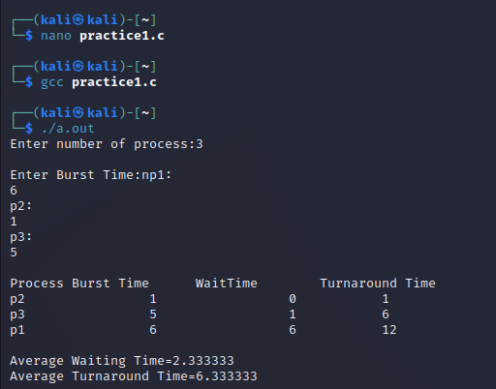

**2. #include <stdio.h>**

**int main()**

**{**

**int pid[15];**

**int bt[15];**

**int n;**

**printf("Enter the number of processes: ");**

**scanf("%d",&n);**

**printf("Enter process id of all the processes: ");**

**for(int i=0;i<n;i++)**

**{**

**scanf("%d",&pid[i]);**

**}**

**printf("Enter burst time of all the processes: ");**

**for(int i=0;i<n;i++)**

**{**

**scanf("%d",&bt[i]);**

**}**

**int i, wt[n];**

**wt[0]=0;**

**//for calculating waiting time of each process**

**for(i=1; i<n; i++)**

**{**

**wt[i]= bt[i-1]+ wt[i-1];**

**}**

**float twt=0.0;**

**float tat= 0.0;**

**for(i=0; i<n; i++)**

**{**

**printf("Process:%d\n", pid[i]);**

**printf("burst time:%d\n", bt[i]);**

**printf("waiting time:%d\n", wt[i]);**

**//calculating and printing turnaround time of each process**

**printf("turnaround time:%d\n", bt[i]+wt[i]);**

**printf("\n");**

**//for calculating total waiting time**

**twt += wt[i];**

**//for calculating total turnaround time**

**tat += (wt[i]+bt[i]);**

**}**

**float att,awt;**

**//for calculating average waiting time**

**awt = twt/n;**

**//for calculating average turnaround time**

**att = tat/n;**

**printf("Avg. waiting time= %f\n",awt);**

**printf("Avg. turnaround time= %f",att);**

**}**

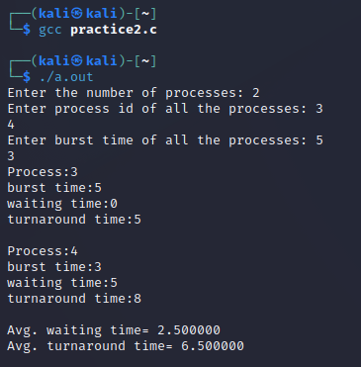

**3.** **#include <stdio.h>**

**int main()**

**{**

**int A[100][4]; // Matrix for storing Process Id, Burst**

**// Time, Average Waiting Time & Average**

**// Turn Around Time.**

**int i, j, n, total = 0, index, temp;**

**float avg_wt, avg_tat;**

**printf("Enter number of process: ");**

**scanf("%d", &n);**

**printf("Enter Burst Time:\n");**

**// User Input Burst Time and alloting Process Id.**

**for (i = 0; i < n; i++) {**

**printf("P%d: ", i + 1);**

**scanf("%d", &A[i][1]);**

**A[i][0] = i + 1;**

**}**

**// Sorting process according to their Burst Time.**

**for (i = 0; i < n; i++) {**

**index = i;**

**for (j = i + 1; j < n; j++)**

**if (A[j][1] < A[index][1])**

**index = j;**

**temp = A[i][1];**

**A[i][1] = A[index][1];**

**A[index][1] = temp;**

**temp = A[i][0];**

**A[i][0] = A[index][0];**

**A[index][0] = temp;**

**}**

**A[0][2] = 0;**

**// Calculation of Waiting Times**

**for (i = 1; i < n; i++) {**

**A[i][2] = 0;**

**for (j = 0; j < i; j++)**

**A[i][2] += A[j][1];**

**total += A[i][2];**

**}**

**avg_wt = (float)total / n;**

**total = 0;**

**printf("P BT WT TAT\n");**

**// Calculation of Turn Around Time and printing the**

**// data.**

**for (i = 0; i < n; i++) {**

**A[i][3] = A[i][1] + A[i][2];**

**total += A[i][3];**

**printf("P%d %d %d %d\n", A[i][0],**

**A[i][1], A[i][2], A[i][3]);**

**}**

**avg_tat = (float)total / n;**

**printf("Average Waiting Time= %f",avg_wt);**

**printf("\nAverage Turnaround Time= %f",avg_tat);**

**}**

